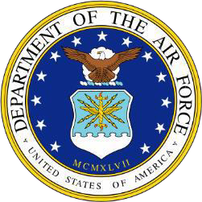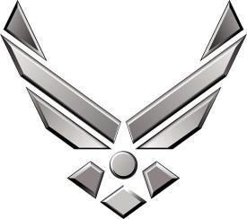

BIOGRAPHY

Major Thomas M. Brewer

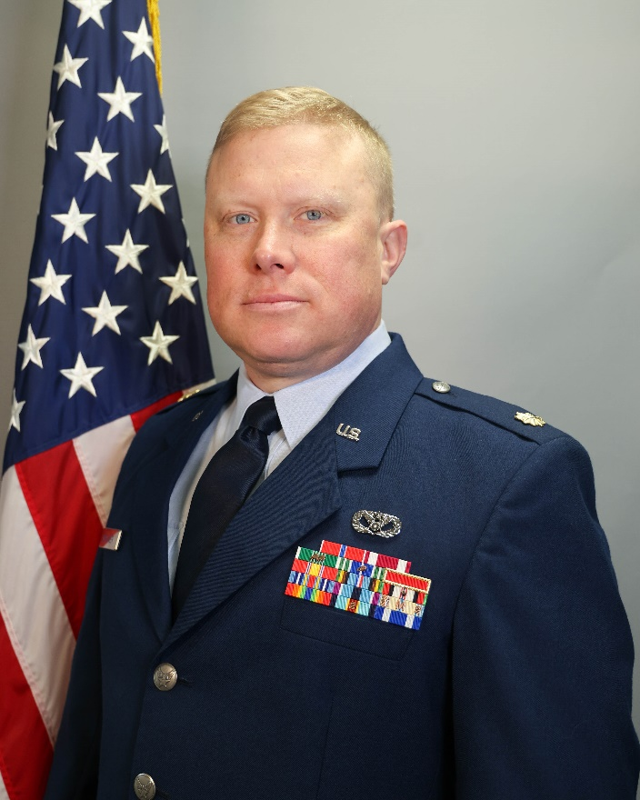
Major Thomas M. Brewer is the Base Civil Engineer, Combat Readiness Training Center (CRTC), Trent Lott National Guard Training Complex, Gulfport, Mississippi. The CRTC is a Joint National Training Center dedicated to supporting regionalized Joint Combat Training while providing airspace, overland and overwater ranges, state-of-the art facilities and equipment and instrumentation for training exercises, career field development, and warfighter conferences. Additionally, the CRTC plays a crucial role in hosting wing-level training and serves as a key facility for the Mississippi National Guard and the Mississippi Emergency Management Agency during natural disasters. Major Brewer has oversight of CRTC infrastructure maintenance and repair, planning and programming projects, and Fire Emergency Services. This includes 35 military, civilian and state CE employees as well as 28 fire department employees.

Major Brewer enlisted in the Mississippi Army National Guard in January of 2011. After graduation from Basic Combat Training at Fort Jackson, South Carolina, Major Brewer attended Officer Candidate School at Camp Fretterd, Maryland and Fort Indiantown Gap, Pennsylvania. Upon commissioning in the fall of 2011, he was accepted into the Engineer Regiment and transferred to the 890th Engineer Battalion where he remained until he transferred to the Air National Guard to take over the Base Civil Engineer position at the Gulfport CRTC. Major Brewer has an 11-month combat deployment to Afghanistan (Operation Enduring Freedom) where he trained 201st CEK Afghan National Army in horizontal engineering operations and a 14-month contingency deployment to Kosovo (Operation Joint Guardian) where he was DPW Director of Camp Bondsteel and Area Support Group Balkans installations.

EDUCATION
2001 | Associate of Arts, General Studies, Meridian Community College, Meridian, MS.
2009 | Bachelor of Science, Construction Engineering Technology, University of Southern Miss, Hattiesburg, MS.
2011 | Officer Candidate School, Reisterstown, MD; Fort Indiantown Gap, PA.
2012 | Army Engineering School (EBOLC), Fort Leonard Wood, MO.
2016 | Army Logistics School (LOGCCC), Fort Lee, VA.
2017 | Army Financial Management (FMBQ), Fort Jackson, SC.
2021 | Civil Engineering 101 (CE101), Wright-Patterson AFB, OH.
2022 | Squadron Officer School (SOSPDE), Air University, Distant Learning.
2024 | Air Command and Staff College (IDE), Air University, Distant Learning.
ASSIGNMENTS
- SEP 2011 – JAN 2013, Assault Platoon Leader, 287th Mobility Augmentation Company, Lucedale, MS.
- JAN 2013 – MAR 2014, Company Intelligence Officer, 859th Vertical Engineering Company, Pascagoula, MS.
  - FEB 2013 – DEC 2013, Horizontal ANA Training Officer, Jalalabad, Afghanistan.
- MAR 2014 – SEP 2014, Horizontal Platoon Leader, 857th Horizontal Engineering Company, Picayune, MS.
- SEP 2014 – SEP 2015, Commander, 251st Quarry Engineering Detachment, Lumberton, MS.
- SEP 2015 – Sep 2016, Plans Officer, 890th Engineering Battalion, Gulfport, MS.
- SEP 2016 – JUN 2017, Assistant Operations Officer, 890th Engineering Battalion, Gulfport, MS.
- JUN 2017 – APR 2019, Commander, 857th Horizontal Engineering Company, Picayune, MS.
- APR 2019 – JAN 2021, Excess Officer, Joint Forces Headquarters, Jackson, MS.
  - APR 2019 – JUN 2020, DPW Director, Camp Bondsteel, Kosovo.
  - JUL 2020 – JAN 2021, CSJFTC Covid-19 Task Force LNO, Hattiesburg, MS.
- JAN 2021 – JAN 2022, Deputy Base Civil Engineer, CRTC, Gulfport, MS.
- JAN 2022 – Present, Base Civil Engineer, CRTC, Gulfport, MS.

MAJOR AWARDS AND DECORATIONS
Bronze Star Medal
Meritorious Service Medal
Air Force Commendation Medal
Army Commendation Medal with Bronze Oak Leaf Cluster
Army Achievement Medal with Bronze Oak Leaf Cluster
Air Force Meritorious Unit Award
Army Meritorious Unit Citation
National Defense Service Medal
Armed Forces Expeditionary Medal
Afghanistan Campaign Medal with Bronze Star Device
Global War on Terrorism Service Medal
Humanitarian Service Medal
Army Oversees Service Ribbon with ‘2’ Device
Air and Space Longevity Service Award
Armed Forces Reserve Medal with ‘M’ Device and Hourglass
Army Service Ribbon
NATO Balkans Medal
NATO ISAF Medal

PROFESSIONAL MEMBERSHIPS AND ASSOCIATIONS

Life Member of the National Guard Association of Mississippi

Life Member Alumni of University of Southern Mississippi

EFFECTIVE DATES OF PROMOTION
Second Lieutenant – September 23, 2011
First Lieutenant – September 23, 2013
Captain – September 09, 2016
Major – May 25, 2022

(Current as of July 2025)

